**Blood Relation**

We use notations to denote the relations between the persons

+ve = Male

-ve = Female

==(Double Line) = We use double line in between Husband-Wife

---(Single Line) = We use single line in between siblings.

1)

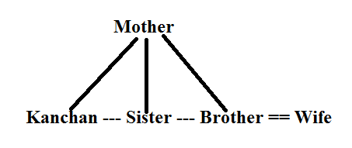

Kanchan's sister's only brother's wife's mother -in-law is mother of Kanchan and her siblings.

So, Answer is mother.

2)

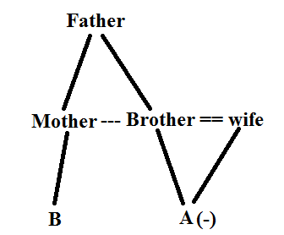

A as the person who is the daughter of B's mother's only brother's father's daughter-in-law. Daughter-in-law is wife of Brother and their daughter is A. Parents of A and B are siblings.

So, A and B are cousins.

3)

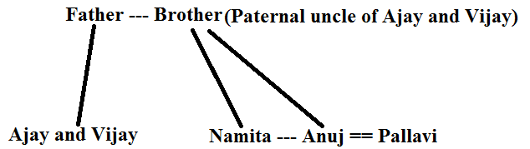

Namita is daughter of Ajay and Vijay's paternal uncle. In that photograph Vijay is standing with Namita's only brother Anuj and Anuj's wife Pallavi. Pallavi's father-in-law is Paternal uncle of Ajay

4)

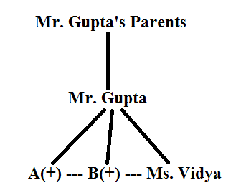

Ms. Vidya's boss Mr. Gupta is the only child of his parents and A and B are two son's of Mr. Gupta. A and B are siblings of Vidya. So, Mr. Gupta is father of A, B and Ms. Vidya.

5)

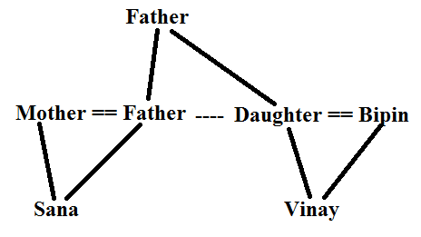

Sana and Vinay went for shopping in a mall and there they meet Bipin who is husband of Sana's mother's father-in-law's only daughter, who is mother of Vinay. So, Bipin is father of vinay.

Directions for Questions 6 to 10

From the information given in the question relation between A, B, C, D, E, F, G and H is,

We use notations to denote the relations between the persons

+ve = Male

-ve = Female

==(Double Line) = We use double line in between Husband-Wife

---(Single Line) = We use single line in between siblings.

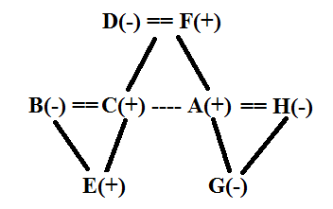

Now we will arrange them around a circle.

D and F are married couples. D, the wife of F, sit second to the left of her husband.

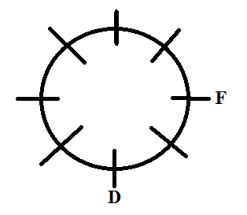

E, a bachelor, sits third to the right of his uncle A, but neither to the opposite nor to the immediate left of his father C and A is not an immediate neighbour of his mother D. So, we will place A and E.

Total Three cases are possible by which we can place A and E

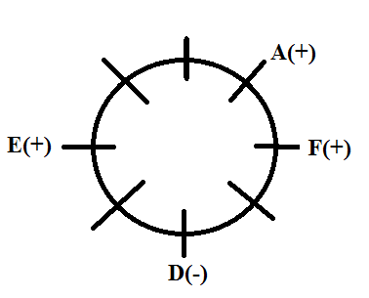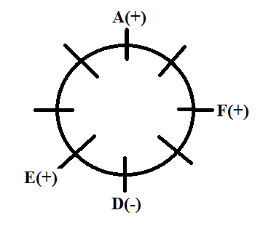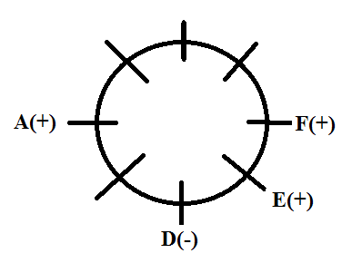

There is only one person sitting between C and his niece G, but that person is not G's father i.e. A.

C and his sister-in-law i.e. H are immediate neighbour.

Now we will place C, G and H.

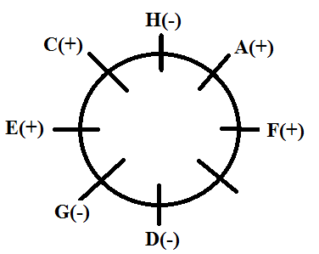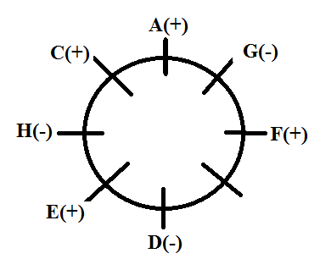 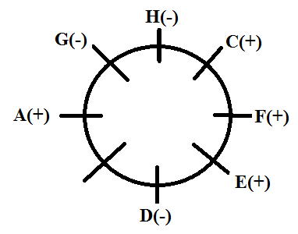

From the above 3 cases we cancel out the second case because in that A i.e father of G is in between G and C, But in the information its written as A should not be immediate neighbour of G and C.

Now we will place remaining person B around the circle.

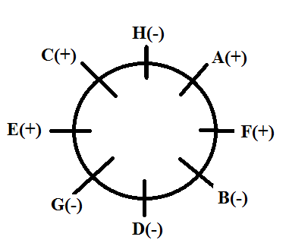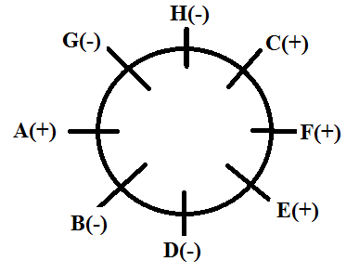

3 females should not be together. In the 1st case 3 females are sitting together so we eliminate the 1st case. So, final arrangement is,



**Direction sense**

1)

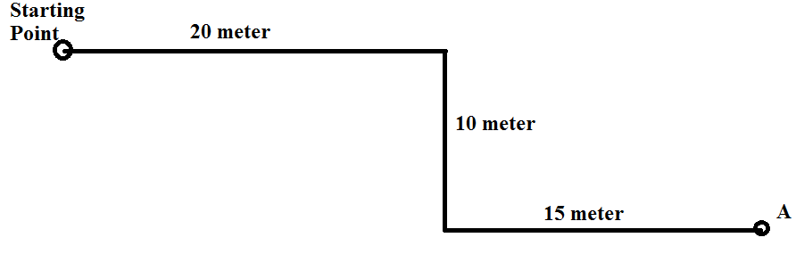

If we joint starting point and A. then distance between Starting point and A we have find out.

Now total Horizontal distance travelled = 35 meter and vertical distance travelled = 10 meter.

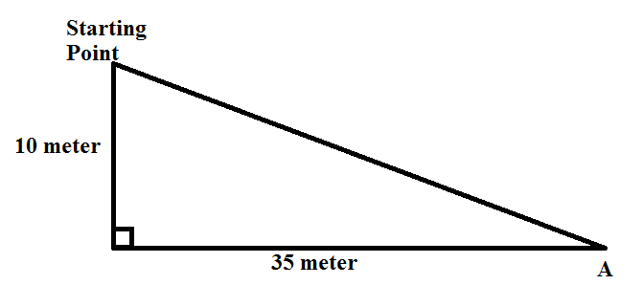

By Pythagoras we can fond out distance between starting point and A

Distance = = 5

2)

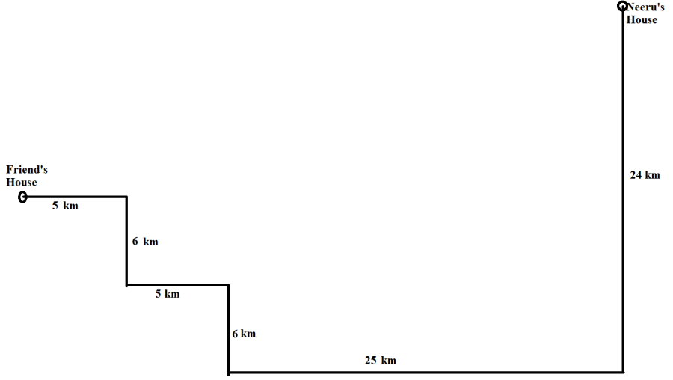

Horizontal distance between Friend's house and Neeru's house = 5+5+25 = 35 km

Vertical distance between Friend's house and Neeru's house = 24 - 6 - 6 = 12 km

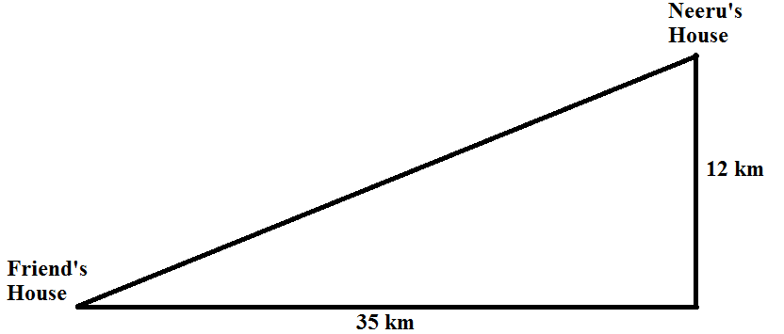

By Pythagoras theorem we can find out the distance between Friend's house and Neeru's house.

Distance = = 37 km

3)

At 12 o'clock minute and hour hand will point towards 12 hour mark

A wall clock is place in such a way that at 12 o'clock the minute hand points towards the south.

So, 12 hour mark is towards south direction

Remaining directions are as shown in the clock below,

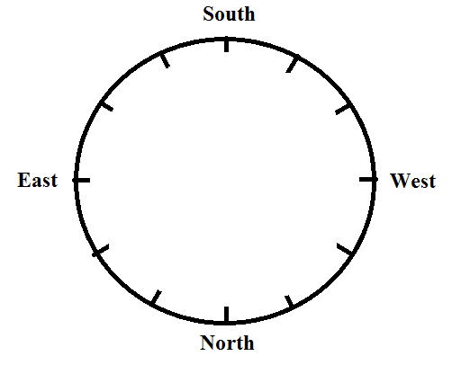

At 3 o'clock minute hand will point toward 3 hour mark and hour hand will point towards 12 hour mark. So hour hand will point towards west.

4) One evening, Bipin and Lalit were standing facing each other, it was observed that the shadow of Bipin was falling to his left. In the evening sun is in the west direction and remaining directions are shown in the diagram.

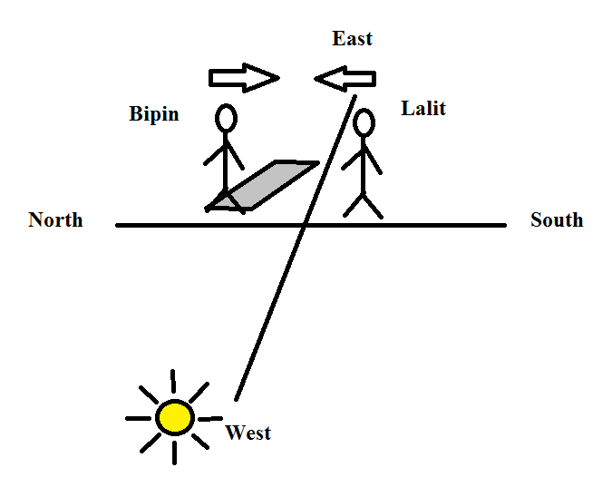

So, Lalit is facing towards North.

5)

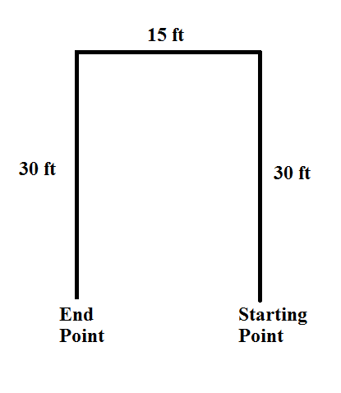

Akash walked 30 ft towards north, then took a left turn and walked 15 ft. He again took a left turn and walked 30 ft. After that Akash is 15 ft to the North from starting point.

**Clock**

1)

We use the formula

= M - 30H

Where,

M= 30 minuutes

H= 6 hours

= Angle between Minute Hand and Hour Hand( This we have to find out)'

After putting and solving we get the value if =150

2)

We use the formula

= M - 30H

Where,

M= 34 minutes

H= 2 hours

= Angle between Minute Hand and Hour Hand(This we have to find out)

After putting and solving we get the value if = 1270

3)

Suppose at time 3 hours x minutes angle between minute and hour hand be 1800 i.e. they are exactly opposite to each other.

Now we use the formula

= M - 30H

Where,

M= x minutes(This we have to find out)

H= 3 hours

= Angle between Minute Hand and Hour Hand = 1800

= - 30

After removing mod sign we get value as +180 or -180.

So,

= - 30

x = = 49

= - 30

x = = - 24

Negative value for minutes is not possible so we will consider value of x = 49 minutes

So, in between 3 and 4, two times angle between minute hand and hour hand would be 1800.

4) Hour hand move 10 in 2 minutes.

To move 280 hour hand takes 56 minutes.

Minute hand 60 in 1 minute.

So, in that 56 minutes minute hand move by 656 = 3360

5)

At time 8 hours x minutes minute and hour hand makes angle of 360

So, we use the formula.

= M - 30H

Where,

M= x minutes(This we have to find out)

H= 8 hours

= Angle between Minute Hand and Hour Hand = 360

= x - 30

After removing mod sign we get value as +180 or -180.

So,

= - 30

x = = 50

= - 30

x = = 37

So, in between 8 and 9, two times angle between minute hand and hour hand would be 360.

Timings are 8 hour 50 and 8 hour 37

Answer for the question is option d.

**Calendar**

1)

In first century to third century, number of leap years and ordinary years in every century are 24 and 76 respectively. Only in fourth century leap years are 25 and ordinary years are 75.

Each leap year contains 2 odd days and ordinary year contains 1 odd day.

|  |  |  |  |  |
| --- | --- | --- | --- | --- |
|  | Leap years | Ordinary Years | Odd days | Odd days |
| 1 to 100 | 24 | 76 | Remainder () = = 5 | 5 |
| 101 to 200 | 24 | 76 | Remainder () = = 5 | 5 |
| 201 to 300 | 24 | 76 | Remainder () = = 5 | 5 |
| 301 to 400 | 25 | 75 | Remainder ( = = 6 | 6 |
|  |  |  | Total number of odd days = 21 | = Remainder = 0 |

In four hundred years odd days are 0. So 400 years before current year must be the same day.

So, day on 27th February 1603 = Thursday

2)

From January 1, 2005 to Jan. 1, 2006 number of days are 365.

Odd days in between that two dates = 1

Day on Jan. 1, 2006 = Sunday

3)

From January 1, 2007 to Jan. 1, 2011 one leap year and 3 ordinary years are there.

Odd days in between that two dates = 5

Day on Jan. 1, 2011 = Saturday

4)

Odd days in 57 days = 1

Next day of Friday i.e Saturday.

So, after 57 days Saturday must be there.

5)

Odd days in 94 days = 3

Next third day of Sunday i.e Wednesday.

So, after 94 days Wednesday must be there.

6) Centurion year must be divisible by 400 to be a leap year. 500 is not divisible by 400 so it is not a leap year.

7)

From 16th Nov, 2009 to 16th Nov, 2010 number of days are = 365.

Odd days in between that two dates = 1

We are moving 1 year back so,

Day on 16th Nov, 2009 = Wednesday

8) January 1, 2010 was Friday.

From January 1, 2010 to Jan. 1, 2011number of days are = 365.

Odd days in between that two dates = 1

Day on Jan. 1, 2011= Saturday

9) On 14th Feb, 2009 it was Saturday.

From 14th Feb, 2008 to 14th Feb, 2009 number of days are = 366.

Odd days in between that two dates = 2

Day on 14th Feb, 2008 = Thursday

10) January 1, 2008 is Tuesday.

From January 1, 2008 to Jan 1, 2009 number of days are = 366.

Odd days in between that two dates = 2

Day on Jan. 1, 2011= Thursday

11)

Calendar for the that year is same as 2011 when day on 1st January of that year and 1st January of 2011 is same. For that odd days between 2011 and that year must be 0 or multiple of 7.

So in between year 2011 and 2022 odd days are 14.

Calendar of 2022 is same as 2011.

13) On 5th December 1993, Nirmala and Raju celebrated their anniversary on Sunday.

In between 1993 and 1997, one leap year and 3 ordinary years are there.

So, odd days in between that 2 years = 5

In 1997 Nirmala and Raju celebrate there anniversary on friday.

**Coding Decoding**

Question 1 to 5

Codes used for the words they are not in the sequential order they are in jumbled up order.

|  |  |
| --- | --- |
| Word | Code used for word |
| Not | la |
| This | sa |
| Good | pa |
| Is | ni |
| Too | ri |
| Are | ka |
| You | bi |
| We | fa |
| Bad | ma |
| It | da/ta |
| Hot | ta/da |

1) Code for you = bi

2) Code for hot ta/da

So, answer is cannot be determine.

3) ri is code for too.

4) code for too bad = ri ma / ma ri

Order for these code can be anything because code for the words are in jumbled up order.

5)

In code section code for this and is i.e sa and ni must be present.

Code used for cold is something different than we have used all the codes.

So, code for 'this is cold' = si ni ga i.e. option e

6) In a certain code ALPHABET is written as YJNFYZCR.

Every letter is coded as previous second letter.

So code for word CHILDREN = AFGJBPCL

7) In a certain code BUSINESS is written as FSWGRCWQ.

Letters at odd places coded with next fourth letter and letters at even places coded with previous second letter.

So, BANGALORE coded as FYREEJSPI

8) In a certain code GUNPOWDER is written as DEGNOPRUW.

Letters of the word GUNPOWDER are arranged in alphabetical order.

In that manner word HOSTPITAL is coded as AIOHLPST.

9) In a certain code REASONING is written as ASREONGNI.

Coding pattern is as shown bellow,

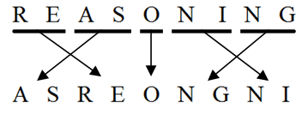

So word FRIZZLING coded as following the same pattern as IZFRZNGLI

10) In a certain code SENSITIVE is written as HVMHRGREV.

If we arrange all alphabets in row then coding pattern is whatever position of letter from left is same position from right is also there and vice versa.

So, word HYDROGEN is coded as SBWILTVM.

11) In a certain code BIOLOGY is written as XFNKNHA.

Encoding pattern is shown bellow

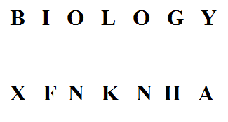

In the same manner CHEMISTRY is coded as XQSRHLDB.

12) If QKKQUGQL is the code for OMISSION.

Letters at the odd places are coded by previous second letter and letters at even places are coded by next second letter this is the encoding logic.

Hence word RYVIWZB is coded as PATKUBZ.

**Data Sufficiency**

**Quant Data Sufficiency**

1) Will the sum becomes eight times of itself within fifteen years?

Statement :1 = The sum becomes twice of itself in two years.

There are two possible cases either interest will be compound interest or simple interest.

|  |  |
| --- | --- |
| Type of interest is Simple interest | Type of interest is Compound interest |
| The sum becomes,  3 times in 4years,  4 times in 6 years  5 times in 8 years  6 times in 10 years  7 times in 12 years  8 times in 14 years  In less than 15 years it becomes 8 times. | The sum becomes,  4 times in 4years,  8 times in 6 years  In less than 15 years it becomes 8 times. |

So from statement 1 we are getting unique answer as YES.

Hence statement 1 is sufficient.

Statement :2 = The type of interest is compound interest, compounded annually.

In this case we don't know the rate of interest so answer can be YES or NO.

Hence statement 2 is not sufficient.

2) Mr. Bipin divided his property among Vineeth, Vipin, and Vikram. Who got the least share of property?

Statement :1 = Vineeth's share is Rs.80000 more that of Vipin.

So least share of property either Vikram or Vipin can get. From this statement we can't say who got the least share of property hence this statement is not sufficient.

Statement :2 = Vipin's share is Rs. 50000 less than that of Vikram.

So least share of property either Vikram or Vineeth can get. From this statement we can't say who got the least share of property hence this statement is not sufficient.

After combining the two statements we can clearly come to know that Vipin get the least share of property.

3) Is 500 the average (Arithmetic mean) score on the GMAT?

Statement :1 = i) Half of the people who take GMAT score above 500 and half of the people score below 500.

|  |  |  |
| --- | --- | --- |
|  | Case -1 | Case - 2 |
| Half scores more than 500 | Suppose all scores 600 | Suppose all scores 600 |
| Half scores less than 500 | Suppose all scores 400 | Suppose all scores 450 |
|  | Average mark of all the students is 500 in this case. | Average mark of all the students won't be 500 in this case. |

So in first case we get answer as YES and in second case we get answer as NO.

So, 1st statement is not sufficient to answer the question.

Statement :2 = ii) The highest GMAT score is 800 and the lowest score is 200.

Now from these statement we know the information of only the student who score highest and lowest marks but average marks also dependent upon the marks of the score of other students also.

So, we can get YES or NO as a answer.

Hence 2nd statement is not sufficient.

After combining we know that half score above 500, half score below 500 and highest and lowest score in GMAT.

From this we can get YES or NO as a answer.

Hence after combining both the statements question will not get solved.

4) What is the area of the rectangle?

Statement :1 = When the length is increase by 20% and the breadth is decrease by10% then the area increases by 8%.

To find out the area of rectangle we need the exact value of length and breadth.

Whatever is the length and breadth, if we increase by 20% and the breadth is decrease by 10% then the area get increases by 8%. From this we will not get the exact values of length and breadth, so 1st statement is insufficient to answer the question.

Statement :2 = The length of rectangle is 14 cm.

From the second statement we know only length of rectangle but to find the area breadth is also required and we don't know that so second statement is insufficient to calculate the area.

After combining the both the statements we know only the length of rectangle i.e. 14 cm, and that is isufficient to calculate the area.

5) Which of the two trains, A or B is faster?

Statement :1 = The ratio of the time taken by the trains A and B in crossing a platform is 5:6

Speed of both the trains is also dependent upon the length of these two trains.

We will see the two different cases.

Length of platform is suppose 100m.

Speed of train A and B be 5x and 6x.

|  |  |
| --- | --- |
| Case 1 | Case 2 |
| Length of train A = 100 m.  Length of train B = 20 m.  Speed of train A = =  Speed of train B = =  In this case speed of train A is more than. | Length of train A = 20 m.  Length of train B = 100 m.  Speed of train A = =  Speed of train B = =  In this case speed of train B is more than A. |

From above two cases we can't say which train is faster, It is totally dependent upon length of the train.

So, statement 1 is not sufficient to answer the question.

Statement :2 = The length of the trains A and B are in the ratio of 7:6

In this statement we know the ratio io the lengths of the two trains, don't know the tome taken by this two trains to cross the platform. So this statement is not sufficient to answer the question

If we combine these two statements then we come to know that train A is longer than train B and it takes less time to cross the platform so, train A faster the B this we got after combining two statements together.

6) Is x=y?

Statement :1 = (x+y)(+)=4

After solving we get x = y. so statement 1 is sufficient to answer the question.

Statement :2 = (x-50)2=(y-50)2

If we take square root on both the side then we get

(x-50)= (y-50)

So we can't say whether x = y or not.

Hence second statement is not sufficient.

7) What are the values of M and N?

Statement :1 = N is an even positive integer, M is an odd positive integer and M is greater than N.

We cant find out exact values for M and N

Hence this statement is not sufficient.

Statement :2 = Product of M and N is 30.

Possible values for the M and N are (1,30), (2,15), (2,15), (3,10), (5,6), (6,5), (10,3), (15,2), (30,1).

We dont know the exact value of M and N so 2st statement is insufficient to answer the question.

After combining the two statements, according to the conditions given in both the statements only one pair is possible for M and N and i.e. (2,15)

8) One side of a rectangle is 9 cm. Find the area of the rectangle?

Statement :1 = One side is square of the another side.

Now that one side is either length of breadth, so two cases are there

Case 1

If one side = length = 9 cm

Then breadth = 3 cm

Area = length breadth = 93 = 27

Case 2

If one side = braedth = 9 cm

Then length = 81 cm

Area = length breadth = 81 = 729

In one case area = 27 cm2 and in other case we are getting area as729 cm2.

So first statement is insufficient to answer the question.

Statement :2 = Length of rectangle is 9 cm.

From this statement we don't know the breadth so we can't find out the area of rectangle.

If we combine two statements together then we know that length is 9 cm and one side of the rectangle is square of another side so breadth must be 3 cm, then area of rectangle becomes 27 cm2

So by combining two statements question gets solved.

9) Distance between point A and B is 9 cm and point B and C is 5 cm. What is the Distance between point A and C?

Statement :1 = Point A, B and C are collinear.

|  |  |
| --- | --- |
| Case 1 | Case 2 |
| In this case distance between point A and B is 9 cm. | In this case distance between point a and B is 4 cm |

We are getting two different answers so first statement is not sufficient to answer the question.

Statement :1 = ii) Point A, B and C are non-collinear.

3 points are non colinear so we will get different values for distance between A and C.

Hence 2nd statement is not sufficient.

If we combine these two statements together then they are contradictory to each other hence after combining also question will not get solved.

10) Is x3 > x2 ?

Statement :1 = i) x > 0

|  |  |
| --- | --- |
| If x = 1/2 | If x = 2 |
| x2 = 1/4  x3 = 1/8  Answer for question = NO | x2 = 4  x3 = 8  Answer for question = YES |

In this case we are getting two different answers so 1st statement is not sufficient to answer the question.

x < 1

|  |  |  |
| --- | --- | --- |
| If x = - 2 | If x = 0 | If x = 1/2 |
| x2 = 4  x3 = - 8  Answer for question = NO | x2 = 0  x3 = 0  Answer for question = NO | x2 = 1/4  x3 = 1/8  Answer for question = NO |

In all the cases we are getting answer as NO so 2nd statement is sufficient to answer the question.

**LR Data Sufficiency**

1) Is X is a leap year?

Statement :1 = i) Four years after X there is a leap year.

|  |  |
| --- | --- |
| If x = 1600 | If x = 1700 |
| Four years after x there is leap year and x is also a leap year.  Answer for question = YES | Four years after x there is leap year, but x is not a leap year.  Answer for question = No |

We are getting two different answers for the question so 1st statement is not sufficient to answer the question.

Statement :2 = ii) Four years before X there is a leap year

|  |  |
| --- | --- |
| If x = 1600 | If x = 1700 |
| Four years before x there is leap year and x is also a leap year.  Answer for question = YES | Four years before x there is leap year, but x is not a leap year.  Answer for question = No |

We are getting two different answers for the question so 2nd statement is not sufficient to answer the question.

Now after combing the 2 statements,

|  |  |
| --- | --- |
| If x = 1600 | If x = 1700 |
| Four years before x and four years after x there is leap year and x is also a leap year.  Answer for question = YES | Four years before x and four years after x there is leap year, but x is not a leap year.  Answer for question = No |

Again we are getting 2 different answers so both the statements together are not sufficient to answer the question.

2) K, L, M, N and P are standing in a queue. Who stand exactly in the middle or the queue?

Statement :1 = i) M and N stand between L and P.

From the data given in the first statement possible arrangements are,

**L K M N P,**

**L M K N P,**

**L M N K P,**

From the 1st statement we can't say who is exactly in the middle of queue, so 1st statement is insufficient to answer the question.

Statement :2 = ii) N stand just behind K

From the data given in the first statement possible arrangements are,

**K N L M P,**

**L K N M P,**

**L M K N P,**

**And so on...**

So from the second statement only we can't able to say who is exactly in the middle of the queue.

If we combine these two statements together then only one arrangement is possible and that is,

**L M K N P,**

**L K N M P**

So either K or N is exactly in the middle of the queue.

So again after combining these two statements together it is not possible to answer the question.

3) A, B, C, D and E live in an apartment (ground floor is named as first floor, the floor above ground floor in named as second floor and so on). On which floor does E live?

Statement :1 = i) D lives on the bottom floor. C does not live on the top floor.

|  |  |  |  |  |
| --- | --- | --- | --- | --- |
|  | Case 1 | Case 2 | Case 3 | Case 3 |
| 5th floor | (C is not on this floor) | (C is not on this floor) | (C is not on this floor) | E(C is not on this floor) |
| 4th floor |  |  | E |  |
| 3rd floor |  | E |  |  |
| 2nd floor | E |  |  |  |
| 1st floor | D | D | D | D |

Out of 2nd, 3rd, 4th or 5th, A can live on any one of the floor.

Hence 1st statement is insufficient to answer the question.

Statement :2 = ii) The number of floors above B's floor is equal to the number of floors below A's floor.

|  |  |  |  |  |
| --- | --- | --- | --- | --- |
|  | Case 1 | Case 2 | Case 3 | Case 3 |
| 5th floor | B |  |  | A |
| 4th floor |  | B | A |  |
| 3rd floor |  |  |  |  |
| 2nd floor |  | A | B |  |
| 1st floor | A |  |  | B |

From 2nd statement 4 cases are possible. E can live any of the four floors.

Hence second statement is not sufficient to answer the question.

If we combine 1st and 2nd statement together then we have only 2 cases.

|  |  |  |
| --- | --- | --- |
|  | Case 2 | Case 3 |
| 5th floor | E | E |
| 4th floor | B | A |
| 3rd floor | C | C |
| 2nd floor | A | B |
| 1st floor | D | D |

In both the cases E live on 5th floor.

Hence 2 statements together are necessary to answer the question.

4) K, L, M, N, O and P are sitting around circular table facing towards centre, Who sits second to the left of O?

Statement :1 = i) L and P are sitting opposite to each other. N is two places away from M.

we can nit determine uniquely who is second to the left of O.

Hence 1st statement is not sufficient to answer the question.

Statement :2 = ii) M and L are immediate neighbours.

we can nit determine uniquely who is second to the left of O.

Hence this statement also not sufficient to answer the question.

After combining this two statements we get the arrangement,

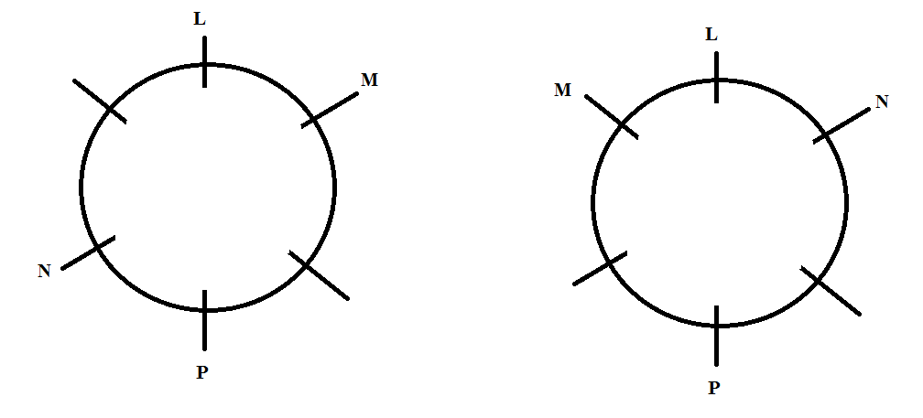

In the vacant places O can sit at anywhere, so after combining question will not get solved.

So answer is together these statements are not sufficient to answer the question.

5) What is the code for 'or' in the code language?

Statement :1 = i) 'nik sa te' means 'right or wrong', 'ro da nik' means 'he is right' and 'fe te ro' means 'that is wrong'.

By comparing the codes given for the words we get the following codes for the words.

Right = nik

Wrong = te

So or is coded as 'sa'.

So first statement is sufficient to answer the question.

Statement :2 = ii) 'pa nik la' means 'that right man', 'sa ne pa' means 'this or that' and 'ne ka re' means 'tell this there'.

By comparing the codes given for the words we get the following codes for the words.

This = ne

That = pa

So or is coded as 'sa'.

So second statement is sufficient to answer the question.

6) Madan is elder than Kamal and Sharad is younger than Arvind. Who among them is the youngest?

Statement :1 = i) Sharad is younger than Madan.

Madan > Kamal

Arvind > Sharad

Arvind > Kamal

So either Kamal or Sharad is youngest.

Hence 1st statement is not sufficient to answer the question.

Statement :2 = ii) Arvind is younger than Kamal.

Madan > Kamal

Arvind > Sharad

Kamal > Arvind

From above data we can easily determine that youngest person is Sharad.

Hence second statement is sufficient.

7) On which date in August was Kapil born?

Statement :1 = i) Kapil's mother remembers that Kapil was born before nineteenth but after fifteenth.

According to mother he was born on 16th, 17th or 18th.

We can't find the exact date on which Kapil was born so 1st statement is insufficient.

Statement :2 = ii) Kapil's brother remembers that Kapil was born before seventeenth but after twelfth.

According to brother he was born on 12th, 13th, 14th 15th or 16th

We can't find the exact date on which Kapil was born so 2nd statement is insufficient.

If we combine the two statements then common date is 16th. So Kapil born on 16th.

Hence together these statements are sufficient.

8) Amol is in whch direction if Amit?

Statement :1 = i) Amol is to the north of Vikas, Vikas is to the west of Naman and Naman is to the south of Amit

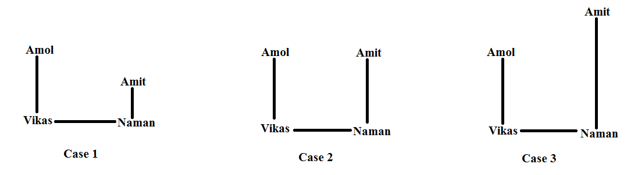

From 1st statement 3 cases are possible according to the first case answer is North-West, according to the first case answer is West, according to the first case answer is South-West,

We are not getting unique answer hence 1st statement is not sufficient to answer the question.

Statement :2 = ii) Distance between Amol and Vikas, Vikas and Naman and Naman and Amit is same.

Only information about distance is given, we dont have any information about directions hence second statement is not sufficient to answer the question.

If we combine the two statements then 2nd case of 1 statement is correct only and we get the answer as west.

Hence both the staements together are necessaey to answer the question.

9) How many persons are there in the row if Ram is 10th from the left and shyam is 6th from the right ?

(Note : All the persons in the row are facing toward north)

Statement :1 = i) In between Ram and Shyam 10 persons are there.

Now either Ram is to the left side of Shyam or Shyam is to the left side of Ram this two cases are there,

Case 1



In this case total 26 persons are there.

Case 2



Now Ram is 10th from the left, so 9 persons are there to the left of Ram, but in this case already 11 persons are there to the left of Ram, so this case is not possible

So we are getting one answer only, hence this statement is sufficient.

Statement :2 = ii) In between Ram and Shyam 3 persons are there.

Now either Ram is to the left side of Shyam or Shyam is to the left side of Ram this two cases are there,

Case 1



In this case total 18 persons are there.

Case 2



Now Ram is 10th from the left, so 9 persons are there to the left of Ram hence remaining 5 persons are to the left of Shyam and Shyam is 6th from the right so 5 persons sre there to the right of Shyam hence 1 person is there to the right of the Ram.

Total 11 persons are there in row.

We are getting two answers from second statement. Hence 2nd statement is not sufficient.

10) How is A related to B?

Statement :1 = i) B is A's father's only brother's wife.

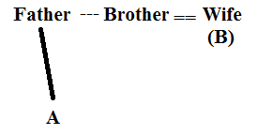

In this case we don't know the gender of A hence we cannot say how is A is related to B.

Hence 1st statement is not sufficient.

Statement :2 = ii) B is the wife of X who is brother of Y who is father of A.

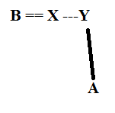

From this we cannot find out the gender of A.

Hence this statement is also not sufficient to answer the question.

After combing also question will not get answered hence these two statements are together also insufficient to answer the question.

**Decision Making**

1) Girish is born and brought up in the state of Kerala. He scored 70% marks in the entrance examination conducted by the college as well as in his graduation. Girish was born in 1994 and he did his graduation in the state of Delhi.

|  |  |  |
| --- | --- | --- |
| Primary Criteria | Alternate Criteria | Decision taken |
| (a) The candidate should have been born and brought up in the state of Maharashtra. **(Not Fulfilled)** | If the candidate has done his graduation in Maharashtra. **(Not Fulfilled)** | Then he/she is to be referred to the Chairman of the college. |
| (b) Have scored at least 65% marks in graduation. **(Fulfilled)** |  |  |
| (c) Have scored at least 60% marks in the entrance examination conducted by the collage. **(Fulfilled)** |  |  |
| (d) Not be more then 22 years old , as on 1st June 2014. **(Fulfilled)** | If the candidate has experience of at least six months as a team leader in any corporate company, then he\she is to be referred to the Principal of the college. | Then he/she is to be referred to the Principal of the college. |

1st primary criteria and alternate criteria of that is not fulfilled hence candidate would not get admission.

2) is born and brought up in Mumbai(Capital of Maharashtra). She scored 80% marks in her graduation as well as in the entrance examination conducted by the college. Her date of birth is 22nd June, 1993.

|  |  |  |
| --- | --- | --- |
| Primary Criteria | Alternate Criteria | Decision taken |
| (a) The candidate should have been born and brought up in the state of Maharashtra. **(Fulfilled)** | If the candidate has done his graduation in Maharashtra. | Then he/she is to be referred to the Chairman of the college. |
| (b) Have scored at least 65% marks in graduation. **(Fulfilled)** |  |  |
| (c) Have scored at least 60% marks in the entrance examination conducted by the collage. **(Fulfilled)** |  |  |
| (d) Not be more then 22 years old , as on 1st June 2014.**(Fulfilled)** | If the candidate has experience of at least six months as a team leader in any corporate company, then he\she is to be referred to the Principal of the college. | Then he/she is to be referred to the Principal of the college. |

All the primary criteria are fulfilled hence candidate may be admitted in to the course.

3) The date of birth of Arun is August 7th, 1993. He is born and brought up in Maharashtra. He has scored 70% marks in his graduation and 80% marks in the entrance examination conducted by the college.

|  |  |  |
| --- | --- | --- |
| Primary Criteria | Alternate Criteria | Decision taken |
| (a) The candidate should have been born and brought up in the state of Maharashtra. **(Fulfilled)** | If the candidate has done his graduation in Maharashtra. | Then he/she is to be referred to the Chairman of the college. |
| (b) Have scored at least 65% marks in graduation. **(Fulfilled)** |  |  |
| (c) Have scored at least 60% marks in the entrance examination conducted by the collage. **(Fulfilled)** |  |  |
| (d) Not be more then 22 years old , as on 1st June 2014. **(Fulfilled)** | If the candidate has experience of at least six months as a team leader in any corporate company, then he\she is to be referred to the Principal of the college. | Then he/she is to be referred to the Principal of the college. |

All the primary criteria are fulfilled hence candidate may be admitted in to the course.

4) Romeo has work experience of one year in a corporate company as a Team Leader. He is born and brought up in the Maharashtra. He scored 65% marks in his graduation and 80% marks in the entrance examination conducted by the college.

|  |  |  |
| --- | --- | --- |
| Primary Criteria | Alternate Criteria | Decision taken |
| (a) The candidate should have been born and brought up in the state of Maharashtra. **(Fulfilled)** | If the candidate has done his graduation in Maharashtra. | Then he/she is to be referred to the Chairman of the college. |
| (b) Have scored at least 65% marks in graduation. **(Fulfilled)** |  |  |
| (c) Have scored at least 60% marks in the entrance examination conducted by the collage.**(Fulfilled)** |  |  |
| (d) Not be more then 22 years old , as on 1st June 2014**.(Don't have any information about date of birth)** | If the candidate has experience of at least six months as a team leader in any corporate company, then he\she is to be referred to the Principal of the college. | Then he/she is to be referred to the Principal of the college. |

We dont have any information about the date of birth of the Romeo hence data is inadequate to take any decision.

5) Sarathi was born in the state of Uttar Pradesh in the year 1994. He did his graduation in the state of Maharashtra. He scored 70% marks in graduation and 85% marks in the entrance examination conducted by college X.

|  |  |  |
| --- | --- | --- |
| Primary Criteria | Alternate Criteria | Decision taken |
| (a) The candidate should have been born and brought up in the state of Maharashtra. **(Not Fulfilled)** | If the candidate has done his graduation in Maharashtra. **(Fulfilled)** | **Then he/she is to be referred to the Chairman of the college.** |
| (b) Have scored at least 65% marks in graduation. **(Fulfilled)** |  |  |
| (c) Have scored at least 60% marks in the entrance examination conducted by the collage. **(Fulfilled)** |  |  |
| (d) Not be more then 22 years old , as on 1st June 2014. **(Fulfilled)** | If the candidate has experience of at least six months as a team leader in any corporate company, then he\she is to be referred to the Principal of the college. | Then he/she is to be referred to the Principal of the college. |

Hence 1st primary criteria is not fulfilled but alternate criteria for that gets fulfilled hence he/she is to be referred to the Chairman of the college.

**Inequality**

**A$B means AB  
A@B means AB**

**A#B means AB**

**A&B means AB  
A*B means AB**

**1) Statements: O = A ≥ R < S ≤ Q  
Conclusions:  
I. Q > R (True)**

**II. S > O (False)**

**III. R = O (False)**

**IV. R < O (False)**A. Only I is true B. Only III is true  
C. Only IV is true D. Either III or IV is true  
E. Either III or IV and I are true

**2) Statements: A ≤ E ≥ F < O > L  
Conclusions:  
I. L < F (False)**

**II. E > O (False)**

**III. A < O (False)**

**IV. E > L (False)**A. None is true B. Only I is true C. Only II is true  
D. Only III is true E. Only IV is true

**3) Statements: B > Q < A = L ≤ N  
Conclusions:  
I. N ≥ A (True)**

**II. L > Q (True)**

**III. B > N (False)**

**IV. Q < N (True)**  
A. I, II and III are true B. I, II and IV are true  
C. I, III and IV are true D. I, III and IV are true E. All are true

**4) Statements:**

**E < M ≤ N > O ≥ P**  
**Conclusions:**  
**I. P < M (False)**

**II. P < N (True)**

**III. M < O (False)**

**IV. N > E (True)**  
A. II and III are true B. II and IV are true  
C. III and IV are true D. I, and IV are true E. All are true

**5) Statements: A ≥ E > F ≤ G < H**  
**Conclusions:**  
**I. H > E** **(False)**

**II. A ≥ G (False)**

**III. E > H (False)**

**IV. A > F (True)**  
A. None is true B. Only I is true C. Only II is true  
D. Only III is true E. Only IV is true

**Input Output**

|  |  |
| --- | --- |
| Step Number |  |
| Input | 53 54 29 jam can man ban 15 86 90 63 van tan den |
| Step 1 | van 53 54 29 jam can man ban 15 86 90 63 tan den |
| Step 2 | van 53 54 29 jam can man ban 15 86 63 tan den 90 |
| Step 3 | tan van 53 54 29 jam can man ban 15 86 63 den 90 |
| Step 4 | tan van 53 54 29 jam can man ban 15 63 den 86 90 |
| Step 5 | man tan van 53 54 29 jam can ban 15 63 den 86 90 |
| Step 6 | man tan van 53 54 29 jam can ban 15 den 63 86 90 |
| Step 7 | jam man tan van 54 53 29 can ban 15 den 63 86 90 |
| Step 8 | jam man tan van 53 29 can ban 15 den 54 63 86 90 |
| Step 9 | den jam man tan van 53 29 can ban 15 54 63 86 90 |
| Step 10 | den jam man tan van 29 can ban 15 53 54 63 86 90 |
| Step 11 | can den jam man tan van 29 ban 15 53 54 63 86 90 |
| Step 12 | can den jam man tan van ban 15 29 53 54 63 86 90 |
| Step 13 (This is Last step and called as output) | ban can den jam man tan van 15 29 53 54 63 86 90 |

1) Which of the following is the last step for the given input?

a) Step 10 b) Step 9 c) Step 11

**d) Step 13** e) None of these

2) Which is the fourth element from the left end in step 7?

a) can b) tan **c) van** d) 53 e) 54

3) How many elements are there between 'tan' and 'can' in step 10 of the given input?

**a) two** b) five c) seven d) nine e) None of these

4) Which step number is the following rearrangement?

'jam man tan van 53 54 29 can ban 15 den 63 86 90'

a) Step 5 **b) Step 7** c) Step 8

d) Step 9 e) No such step

5) In the second last step, in a certain way 'den' is related to '86' and 'tan' is related to '53' in the same way, 'van' is related to.

a) 54 b) man **c) 29** d) 15 e) ban

**and Number Series**

**Direction for Questions 1 to 5**

Find Out the Missing number in the following series.

1) 343, 64, 81, 100, 1331, 144, 2197, 196, ____

In this series composite numbers square and prime numbers cube is there.

Next number must be 152 (Composite number)= 225

2) 2000, 1996, 1980, 1944, 1880, ____

2000 - 4(22) =1996

1996 -16(42) =1980

1980 - 36(62) = 1944

1944 - 64(82) = 1880

1880 - 100(102) = 1780

3) 2, 10, 24, 98, 200, ____, 1608

24+2 = 10

10+4 = 24

244+2 = 98

982+4 = 200

4+2 = 802

4) NQF, LOD, JMB, HKZ, ____

See the first letter of each term, so first letter in the next term must be F

See the second letter of each term, so second letter in the next term must be G

See the third letter of each term, so third letter in the next term must be Y

Next term must be FGY

5) TMCI, VJGD, XGKY, ZDOT, ____

See the first letter of each term, so first letter in the next term must be B

See the second letter of each term, so second letter in the next term must be A

See the third letter of each term, so third letter in the next term must be S

See the fourth letter of each term, so fourth letter in the next term must be Q

Next term must be BASQ

**Direction for Questions 6 and 7**

Each of these Questions consist a series with one wrong number. Find the wrong number.

6) 16, 24, 40, 64, 98, 136

16+8 = 24

24+16 = 40

40+24 = 64

64+32 = 96

96+40 = 136

So wrong number in the series is 98, at that place 96 must be there.

7) 78, 81, 86, 93, 102, 117

78+3 = 81

81+5 = 86

86+7 = 93

93+ 11 = 104

104+13 = 117

Prime number is get added in the current tern to get the next term.

So, wrong term is 102, at that place 104 must be there.

**Questions 8 to 10**

8) Ajay is sitting in a row of thirty six people. He shifted seven places towards the left end. Now he becomes sixth from the left end. What is his present position from the right end?

Ajay is sixth form the left end so 5 persons must be there to the left of Ajay and remaining 30 persons must be to the right of Ajay.

So his position from the right end is 31st.

9) In a row of boys facing south, Ravi is 8th from the left end and Raghav is 5th to the left of Ravi and 16th from the right end of the row. What is the total number of boys in the row?

Ravi is 8th from the left end, so 7 persons are there to the left of Ravi,



Raghav is 5th to the left of Ravi, so in between Raghav and Ravi 4 persons are there,



Raghav is 16th from the right end of the row so 15 persons must be to the right of Raghav.

Already 5 persons are there to the right of Raghav so remaining 10 persons must be to the right of Ravi.



Total 18 boys are there in the row.

10) In a queue, nine members are standing behind Anjali, seven members are ahead of Meena and six members are in between Anjali and Meena. How many members are standing in the queue?

There are two cases in the first case Anjali is ahead of Meena and in the second case we consider Meena is Ahead of Anjali.

Case 1 (Anjali is 7th ahead of Meena)



So total 10 members are there in a queue.

Case 2 (Meena is 7th Ahead of Anjali)



So tatal 24 members are there in the queue

Two answers we are getting so answer is cannot be determine.

**Directions for Questions 1 to 5**

Study the following information and answer the questions given bellow.

A, B, C, D, E, F, G and H are eight students of a school. They study in Std VI, VII and VIII with not more than three in any Std. Each of them has a favourite subject from Physics, Geography, English, Marathi, Mathematics, Chemistry, Biology and Economics not necessarily in the same order.

D likes Chemistry and studies in Std VIII with only H. B does not study in Std VII. E and A study in the same Std but not with B. C and F study in the same Std. Those who study in Std VI do not like Mathematics or Biology. F likes Physics. The one who studies in Std VIII likes English. C does not like Geography. A’s favourite subject is Marathi and G does not like Biology.

D likes Chemistry and studies in Std VIII with only H. Only D and H are in the standard VIII except these two persons no one is studding in standard VIII

|  |  |  |  |
| --- | --- | --- | --- |
| **Person** | **Class** | **Subject** |  |
| A |  |  |  |
| B |  |  |  |
| C |  |  |  |
| D | VIII | Chemistry |  |
| E |  |  |  |
| F |  |  |  |
| G |  |  |  |
| H | VIII |  |  |
|  |  |  |  |

B does not study in Std VII. So B study in std, VI. E and A study in the same Std but not with B. so E and A are studying in std. VII. C and F study in the same Std. C and F must be studying in std. VI because if they are studying in std. VII then total 4 persons are there who are studying in std. VII

Now Table becomes,

|  |  |  |  |
| --- | --- | --- | --- |
| **Person** | **Class** | **Subject** |  |
| A | VII |  |  |
| B | VI |  |  |
| C | VI |  |  |
| D | VIII | Chemistry |  |
| E | VII |  |  |
| F | VI |  |  |
| G |  |  |  |
| H | VIII |  |  |
|  |  |  |  |

So, G must be in the std. VII.

Those who study in Std VI do not like Mathematics or Biology. F likes Physics. The one who studies in Std VIII likes English. So F likes English. C does not like Geography. A’s favourite subject is Marathi and G does not like Biology.

So E is the person who likes Biology.

|  |  |  |  |
| --- | --- | --- | --- |
| **Person** | **Class** | **Subject** | **Do not like** |
| A | VII | Marathi |  |
| B | VI |  | Maths, Biology |
| C | VI |  | Maths, Biology, Geography |
| D | VIII | Chemistry |  |
| E | VII | Biology |  |
| F | VI | Physics | Maths, Biology |
| G | VII |  | Biology |
| H | VIII | English |  |
|  |  |  |  |

G likes Maths. B likes Geography and C likes Ecomonics.

|  |  |  |  |
| --- | --- | --- | --- |
| **Person** | **Class** | **Subject** | **Do not like** |
| A | VII | Marathi |  |
| B | VI | Geography | Maths, Biology |
| C | VI | Economics | Maths, Biology, Geography |
| D | VIII | Chemistry |  |
| E | VII | Biology |  |
| F | VI | Physics | Maths, Biology |
| G | VII | Maths | Biology |
| H | VIII | English |  |

1) Which subject does H like?

**a) English** b) Marathi c) Science

d) Data inadequate e) None of these

2) What is G’s favourite subject?

a) Biology b) Physics c) Marathi

d) Data inadequate **e) None of these**

3) What is C’s favorite subject?

**a) Economics** b) Biology c) English

d) Geography e) Data inadequate

4) Which of the following combinations of student-Std Subject is correct?

a) C-VII-Economics b) D-VI-Chemistry

c) G-VII-Physics d) B-VIII-Mathematic **e) None of these**

5) Which of the following groups of students study in Std VII?

a) EAF b) ECG **c) EAG**

d) Data inadequate e) None of these

**Directions for Questions 6 to 10**

Answer the questions on the basis of the information given below.

Seven people P, Q, R, S, T, U and V live on separate floors of a 7-floor building. Ground floor is numbered 1, first floor is numbered. 2 and so on until the topmost floor are numbered 7. Each one of these is travelling to a different city, namely Delhi, Mumbai, Patna, Chennai, Kolkata, Bangalore and Lucknow but not necessarily in the same order. Only three people live above the floor on which P lives. Only one person lives between P and the one travelling to Bangalore. U lives immediately below the one travelling to Mumbai. The one travelling to Mumbai lives on an even-numbered floor. Only three people live between the ones travelling to Bangalore and Patna. T lives immediately above R. T is not travelling to Patna. Only two people live between Q and the one travelling to Kolkata. The one travelling to Kolkata lives below the floor on which Q lives. The one travelling to Delhi does not live immediately above or immediately below Q. S  
does not live immediately above or immediately below P. V does not travel to Chennai.

Only three people live above the floor on which P lives. M must be on fourth floor. Only one person lives between P and the one travelling to Bangalore. So person travelling to Bangalore must be on the 6th floor or 2nd floor. Two cases are there.

|  |  |  |
| --- | --- | --- |
| Floor | Case 1 | Case 2 |

|  |  |  |  |  |
| --- | --- | --- | --- | --- |
| 7th floor |  |  |  |  |
| 6th floor |  | Bangalore |  |  |
| 5th floor |  |  |  |  |
| 4th floor | P |  | P |  |
| 3th floor |  |  |  |  |
| 2th floor |  |  |  | Bangalore |
| 1th floor |  |  |  |  |

Only three people live between the ones travelling to Bangalore and Patna.

So person travelling to Patna must be on the 2nd or 6th floor.

The one travelling to Mumbai lives on an even-numbered floor. So P is the person that travelling to Mumbai.

U lives immediately below the one travelling to Mumbai.

|  |  |  |
| --- | --- | --- |
| Floor | Case 1 | Case 2 |

|  |  |  |  |  |
| --- | --- | --- | --- | --- |
| 7th floor |  |  |  |  |
| 6th floor |  | Bangalore |  | Patna |
| 5th floor |  |  |  |  |
| 4th floor | P | Mumbai | P | Mumbai |
| 3th floor | U |  | U |  |
| 2th floor |  | Patna |  | Bangalore |
| 1th floor |  |  |  |  |

Only two people live between Q and the one travelling to Kolkata. The one travelling to Kolkata lives below the floor on which Q lives. So person travelling to Kolkata must be on 3rd floor and Q must be on 6th floor.

T lives immediately above R. T is not travelling to Patna. So in the first case we cant place T and R so we cancel the first case and proceed with the second case.

In the second case we can place T and R on 2nd and 1st floor respectively.

|  |  |  |
| --- | --- | --- |
| Floor | Case 1 | Case 2 |

|  |  |  |  |  |
| --- | --- | --- | --- | --- |
| 7th floor |  |  |  |  |
| 6th floor | Q | Bangalore | Q | Patna |
| 5th floor |  |  |  |  |
| 4th floor | P | Mumbai | P | Mumbai |
| 3th floor | U | Kolkata | U | Kolkata |
| 2th floor |  | Patna | T | Bangalore |
| 1th floor |  |  | R |  |

The one travelling to Delhi does not live immediately above or immediately below Q. So the one who travelling to Delhi must be on the 1st floor.

|  |  |
| --- | --- |
| Floor | Case 2 |

|  |  |  |
| --- | --- | --- |
| 7th floor |  |  |
| 6th floor | Q | Patna |
| 5th floor |  |  |
| 4th floor | P | Mumbai |
| 3th floor | U | Kolkata |
| 2th floor | T | Bangalore |
| 1th floor | R | Delhi |

S does not live immediately above or immediately below P. So S must be on the 7th floor and V on the 5th floor. V does not travel to Chennai. So S travelling to Chennai and V travelling to Lucknow.

|  |  |
| --- | --- |
| Floor | Case 2 |

|  |  |  |
| --- | --- | --- |
| 7th floor | S | Chennai |
| 6th floor | Q | Patna |
| 5th floor | V | Lucknow |
| 4th floor | P | Mumbai |
| 3th floor | U | Kolkata |
| 2th floor | T | Bangalore |
| 1th floor | R | Delhi |

6) Which of the following is true with respect to V as per the given information?

**a)  The one who lives immediately below V is travelling to Mumbai**

b)  V lives on floor no. 7

c)  V lives immediately below T

d)  V lives on the lowermost floor

e)  V is travelling to Bangalore

7) Who among the following lives on floor no number 3?

a)  The one travelling to Chennai

**b)   The one travelling to Kolkata**

c)  R d)  V e)  T

8) Who lives on the floor immediately above T?

a)  P b)  Q c)  S d)  V **e)  U**

9) To which of the following cities is S travelling?

a)  Mumbai b)  Bangalore c)  Patna

d)  Kolkata **e)  Chennai**

10) How many people live between the floors on which S and the one travelling to Mumbai live?

a)  None **b)  Two** c) One d)  More than three e)  Three

**Directions for questions 11 to 13**

Answer the questions on the basis of the information given below.

Five women decided to go shopping to M.G. Road, Bangalore. They arrived at the designated meeting place in the following order: 1. Archana, 2. Chellamma, 3. Dhenuka, 4. Helen, and 5. Shahnaz. Each woman spent at least Rs. 1000. Below are some additional facts about how much they spent during their shopping spree.

i. The woman who spent Rs. 2234 arrived before the lady who spent Rs. 1193.

ii. One woman spent Rs. 1340 and she was not Dhenuka.

iii. One woman spent Rs. 1378 more than Chellamma.

iv. One woman spent Rs. 2517 and she was not Archana.

v. Helen spent more than Dhenuka.

vi. Shahnaz spent the largest amount and Chellamma the smallest.

Order in which they arrived at the designated meeting place is given i.e. 1. Archana, 2. Chellamma, 3. Dhenuka, 4. Helen, and 5. Shahnaz

One woman spent Rs. 1378 more than Chellamma.

One woman = Chellamma + 1378 and remaining four amounts are given in the question that are 2234, 1193, 1340 and 2517

Two case are there i.e. either we can take amount spent Chellamma as a smallest from the four amounts or we can take largest amount of the four amount as amount spent by one woman and then calculate amount spent by Chellamma.

Case 1

In this case amount spent by Chellamma is the smallest of given four amounts in the question, then amount spent by one woman = 1193 +1378 = 2571

Five amounts spent by woman are,

2234,

1193,

1340,

2517,

2571.

Case 2

In this case amount spent by one woman is the largest of given four amounts in the question, then amount spent by Chellamma = 2517 - 1378 = 1139

2234,

1193,

1340,

2517,

1139.

Now we solve,

Shahnaz spent the largest amount and Chellamma the smallest.

|  |  |  |
| --- | --- | --- |
| **Order in which 5 women arrived.** | **Case 1** | **Case 2** |
| 1. Archana |  |  |
| 2. Chellamma | 1193 | 1139 |
| 3. Dhenuka |  |  |
| 4. Helen |  |  |
| 5. Shahnaz | 2571 | 2517 |

The woman who spent Rs. 2234 arrived before the lady who spent Rs. 1193.

One woman spent Rs. 1340 and she was not Dhenuka.

One woman spent Rs. 2517 and she was not Archana.

|  |  |  |
| --- | --- | --- |
| **Order in which 5 women arrived.** | **Case 1** | **Case 2** |
| 1. Archana | 2234 | 2234 |
| 2. Chellamma | 1193 | 1139 |
| 3. Dhenuka | 2517 | 1193 |
| 4. Helen | 1340 | 1340 |
| 5. Shahnaz | 2571 | 2517 |

Point 5 is Helen spent more than Dhenuka.

That is not satisfying in the first case so only second case is correct.

|  |  |
| --- | --- |
| **Order in which 5 women arrived.** | **Case 2** |
| 1. Archana | 2234 |
| 2. Chellamma | 1139 |
| 3. Dhenuka | 1193 |
| 4. Helen | 1340 |
| 5. Shahnaz | 2517 |

11) What was the amount spent by Helen?

a) Rs. 1193 **b) Rs. 1340** c) Rs. 2234 d) Rs. 2517

12) Which of the following amounts was spent by one of them?

**a) Rs. 1139** b) Rs. 1378 c) Rs. 2571 d) Rs. 2718

13) The woman who spent Rs. 1193 is

a) Archana b) Chellamma **c) Dhenuka**  d) Helen

**Directions for questions 14 to 16**

Study the following information and answer the questions given bellow.

Five persons - A, B, C, D and E - have collected some money. After counting all the money it is found that B has more money than D, who has more money than C but less than E, who has more money than A but less than B.

B > D > C

E > D

B > E > A

After combing we get,

B > E > D > C

B > E > A

We can't compare the amount with A and C or A and D.

14) Who has the highset amount of money?

a) E **b) B** c) C d) D

15) Who among the following can have least amount of money?

Either A or C will have least amount of money, So mark the answer as A which is given in the options

**a) A** b) D c) B d) None of these

16) What is the maximum possible number of persons who can have more money than A?

To find the maximum possible number of persons who have more money than A, we have to consider that A has least amount of money. So maximum 4 persons are there who have more money than A

a) 3 **b) 4**  c) 2 d) 1

**Directions for questions 17 to 19**

Study the following information and answer the questions given bellow.

Seven persons - P, Q, R, S, T, U and V - are sitting in a row not necessarily in the same order. They are sitting left to right in the decreasing order of their heights. No two among them are of equal height.

V is not the tallest but taller than R. S and V are adjacent to each other. S is taller than U, who is shorter than P , who is not the tallest. R and V are taller than Q, who is not the shortest. P and R are adjacent to each other. T is the second shortest. The one who is tallest is 180 cm. Q's height is 160 cm.

V = Not tallest

V > R

S and V are adjacent to each other.

So, S and V > R

S > U

So, S and V > U

U > P

P = Not tallest

R and V > Q

So, S and V > Q

Q = Not shortest

P and R are adjacent to each other.

So, V > P and R

U > P and R

P and R > Q

T = Second shortest

Tallest person = 180 cm

Q = 160 cm

First fill the given data

___>___>___>___>___> T >___

Total number of persons that are taller than Q are Four and Q is Not the shortest. So Q must be the third shortest person.

___>___>___>___> Q > T >___

V > R

So,

S and V > P and R

T = Not tallest

After arranging these we get,

S > V > P/R > R/P > Q > T > U

So,

Tallest person = S = 180 cm

17) Which of the following could possibly be the T's height?

T's height must be less than 160 cm, so answer is 159 cm

a) 170 cm b) 160 cm c) 172 cm **d) 159 cm**

18) Which of the following is true with respect to the given information?

a) Q and U are adjacent to each other. **b) S's height is 180 cm**

c) V is the shortest. d) Q is the tallest.

19) If the shortest persons height is 14 cm less than that of Q. Which of the following can be T's height?

Shortest person is U = 146 cm

So, T's height must me in between 146 cm and 160 cm

a) 140 cm b) 145 cm c) 146 cm **d) 149 cm**

**Directions for questions 20 to 22**

Study the following information and answer the questions given bellow.

Age and experience of five people - Vinay, Palak, Sunil, Bipin and Jayesh - working for an organization are compared. The following information is known.

a) The second oldest person has the least experience and the oldest person is senior most.

b) No two people are of the same age or have the same experience.

c) The age of Vinay is more than that of Jayesh 's and the experience of Sunil is more than that of Bipin 's

d) The age of each person is more than his experience.

e) The age and experience of Bipin 's is more than age and experience of Jayesh.

f) The age of Palak is less than experience of Jayesh.

|  |  |
| --- | --- |
| **Age** | **Experience** |
| Vinay > Jayesh  Bipin > Jayesh | Sunil > Bipin > Jayesh |

Age of Palak < Experience of Jayesh Means,

Age of Palak < Age of Jayesh

Experience of Palak < Experience of Jayesh

|  |  |
| --- | --- |
| **Age** | **Experience** |
| Vinay > Jayesh > Palak  Bipin > Jayesh > Palak | Sunil > Bipin > Jayesh > Palak |

The second oldest person has the least experience and the oldest person is senior most.

So, Sunil must be the oldest and most experienced person(senior most).

|  |  |
| --- | --- |
| **Age** | **Experience** |
| Sunil > Vinay > Bipin > Jayesh > Palak | Sunil > Bipin > Jayesh > Palak > Vinay |

20) Who is older than exactly two other people?

a) Sunil b) Vinay **c) Bipin**  d) Jayesh

21) Who is the most experienced?

**a) Sunil** b) Palak c) Vinay d) Bipin

22) Who is the youngest?

**a) Palak** b) Vinay c) Bipin d) Jayesh

**Directions for questions 23 and 24**

Study the following information and answer the questions given bellow.

Study the following information and answer the questions given bellow.

X,Y and Z often eat dinner out.

1. Each orders either coffee or tea after dinner.

2. If X orders coffee, then Y orders the drink that Z orders.

3. If Y orders coffee, the X orders the drink that Z doesn't order.

4. If Z orders tea, then X orders the drink that Y orders.

|  |  |  |  |
| --- | --- | --- | --- |
| X | Y | Z |  |
| Tea | Tea | Tea | Correct |
| Tea | Tea | Coffee | Correct |
| Tea | Coffee | Tea | Eliminated because of point 3 |
| Tea | Coffee | Coffee | Correct |
| Coffee | Tea | Tea | Eliminated because of point 4 |
| Coffee | Tea | Coffee | Eliminated because of point 2 |
| Coffee | Coffee | Tea | Eliminated because of point 2 |
| Coffee | Coffee | Coffee | Eliminated because of point 3 |

We will solve the questions,

23) Who do you know always orders the same drink after dinner?

**a) X** b) Y c) Z d) Cannot be determine

24) In the above question which drink that is always ordered?

a) Either Tea or Coffee b) Both Tea and Coffee **c) Only Tea** d) Only Coffee

**Sitting arrangement**

**Directions for questions 1 to 5**

Directions: Study the following information to answer the given questions:

Eight people are sitting in two parallel rows containing four people each, in such a way that there is an

equal distance between adjacent persons. In row- 1, Asha, Bheem, Chelsi and Deep are seated (but not

necessarily in the same order) and all of them are facing South. In row-2, Preet, Qureshi, Raunit and

Sana are seated (but not necessarily in the same order) and all of them are facing North. Therefore, in

the given seating arrangement each member seated in a row faces another member of the other row.

Raunit sits second to left of the person who faces Asha. Sana is an immediate neighbour of Raunit.

Only one person sits between Asha and Deep. One of the immediate neighbours of Chelsi faces

Qureshi. Bheem does not sit at any of the extreme ends of the line.

Row- 1, Asha, Bheem, Chelsi and Deep(Facing south)

Row-2, Preet, Qureshi, Raunit and Sana(Facing North)

Raunit sits second to left of the person who faces Asha.

There are two cases,

Case A



Case B

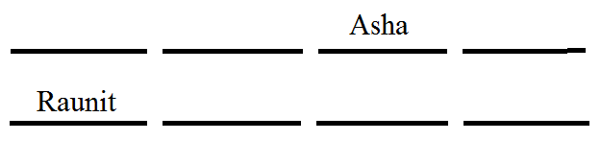

Sana is an immediate neighbour of Raunit.

Case A

Sana can sit to the left of Raunit or to the right of Raunit.

So again two cases are there.

Case 1

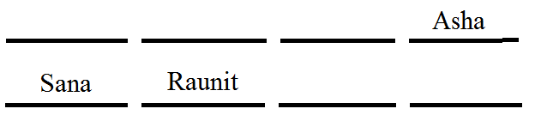

Case 2

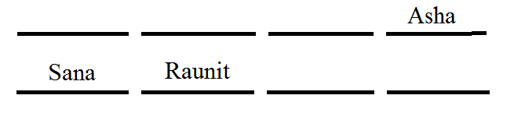

Case B

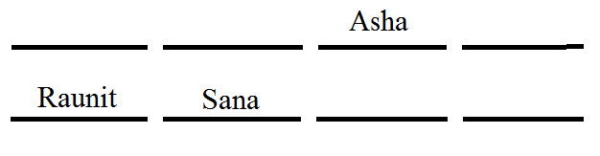

Only one person sits between Asha and Deep

Case A

Case 1

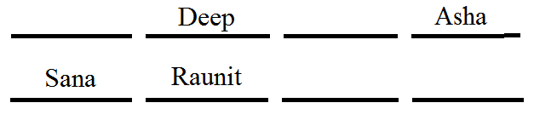

Case 2

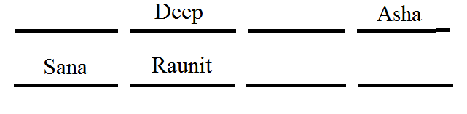

Case B

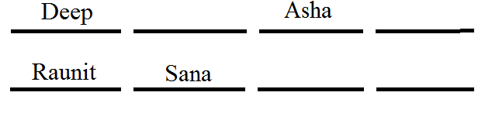

Bheem does not sit at any of the extreme ends of the line.

Case A

Case 1

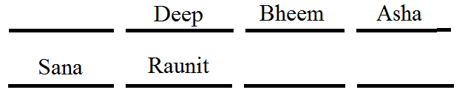

Case 2

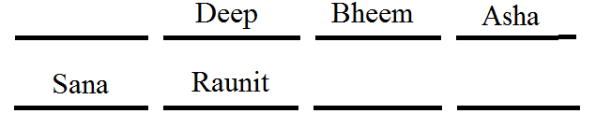

Case B

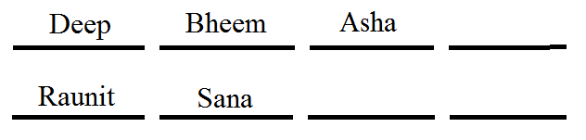

One of the immediate neighbours of Chelsi faces Qureshi.

Only one place is vacant in row 1 i.e. for Chelsi, Immediate neighbour of Chelsi faces Qureshi, from this Case A is get eliminates.

Only Case B becomes right

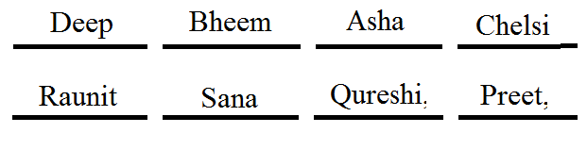

1) Who amongst the following faces Bheem?

a) Preet b) Qureshi c) Raunit **d) Sana** e) Cannot be determine

2) Who amongst the following faces Raunit?

a) Asha b) Bheem c) Chelsi **d) Deep** e) Cannot be determine

3) Which of the following is true regarding Chelsi?

a) Chelsi sits second to right of Deep

**b) Asha sit immediate right of Chelsi**

c) Sana faces Chelsi

d) Deep is an immediate neighbour of Chelsi

e) The person who faces Chelsi is an immediate neighbour of Raunit

4) Four of the following five are alike in certain way based on the given seating arrangement and thus

form a group. Which is the one that does not belong to the group?

Qureshi = Because remaining three persons are at the extreme end.

Chelsi = Because this is the only person belongs to row 1

a) Qureshi b) Raunit c) Chelsi d) Preet **e) Cannot be determine**

5) Who amongst the following sits second to the right of the person who faces Preet?

a) Asha b) Bheem **c) Chelsi** d) Deep e) Cannot be determine

**Directions for questions 6 to 10**

These questions are based on the following information.

Seven persons A, B, C, D, E, F and G are sitting around a circular table facing either the centre or outside. Each one of them belongs to a different city viz, Hyderabad, Mumbai, Delhi, Pune,

Bangalore, Gujarat and Chennai but not necessarily in the same order. G does not belong to Pune. C sits third to the right of G. G faces the centre. Only one person sit between D and F. Both F and D face the centre. Only one person sit between C and the person who belongs to Pune. Immediate neighbours of C face outside. A belongs to Gujarat and faces the centre. The person who belongs to Bangalore sits to the immediate left of E. Two persons sit between the persons who belongs to Gujarat and Mumbai. The person who belongs to Delhi sits to the immediate left of the person who belongs to Chennai..

G faces the centre. Only one person sit between C and the person who belongs to Pune. So, there are two cases.

Case 1

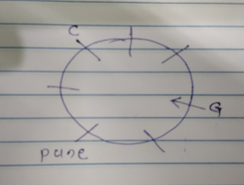

Case 2

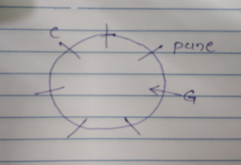

Immediate neighbours of C face outside. Only one person sit between D and F. Both F and D face the centre.

Case 1

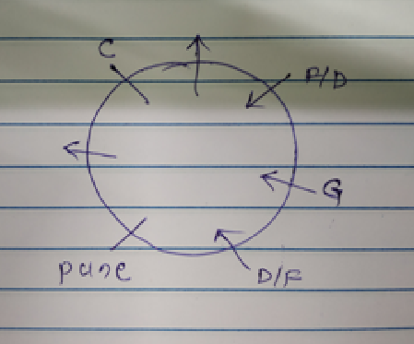

Case 2

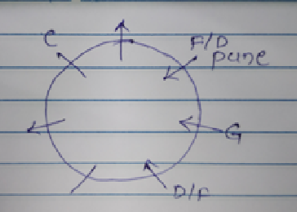

We cannot place A in the first case so it get eliminated, We will proceed with second case.

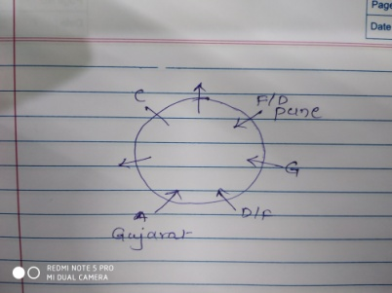

The person who belongs to Bangalore sits to the immediate left of E.

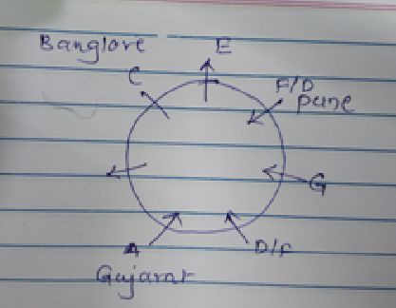

The person who belongs to Delhi sits to the immediate left of the person who belongs to Chennai.

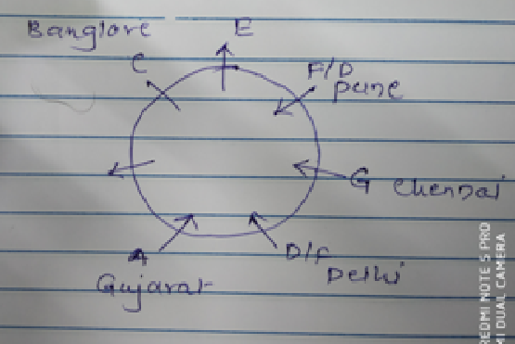

Two persons sit between the persons who belongs to Gujarat and Mumbai.

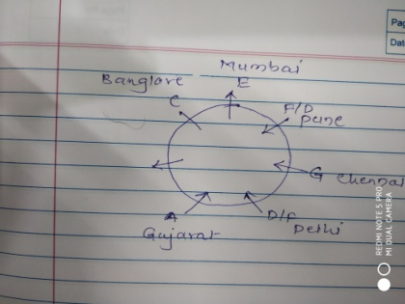

Remaining person is B that belongs to Hyderabad.

And we dint know the direction in which c is facing.

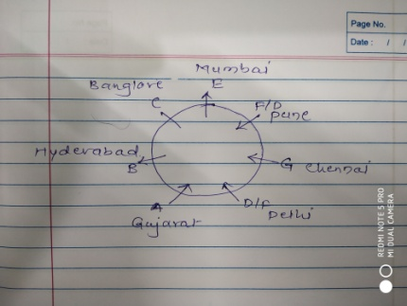

6) To which of the following cities does B belong?

**a) Hyderabad** b) Mumbai c) Pune

d) Bangalore e) Chennai

7) who among the following sit exactly between C and the person who belongs to Pune?

a) The person who belongs to Chennai b) B

**c) The person who belongs to Mumbai** d) G e) D

8) How many persons sit between the person who belongs to Chennai and A, when counted from the right hand side of A?

**a) One** b) Two c) Three d) Four e) More than four

9) Who among the following sit between the persons who belongs to Mumbai and Gujarat when counted from the left hand side of the person who belongs Mumbai?

a) B and D b) G and F c) C and E

d) D and F **e) B and C**

10) Four of the following five are alike in a certain way based on their position in the given arrangement and so form a group. Which is the one that does not belong to that group?

a) Delhi b) Gujarat c) Pune

d) Chennai **e) Bangalore**

**Venn Diagram**

**Direction for the questions 1 to 5**

Read the following information carefully and answer the following question.

In a batch of 300 candidates, 45% of the candidates are appearing for SSC exam, 43% of the candidates are appearing for PO exam and 40% of the candidates are appearing for UPSC exam. 10% candidates are appearing for both SSC and PO, 12% candidates are appearing for both UPSC and PO, 15% candidates are appearing for both SSC and UPSC. 5% candidates are not appearing for any exam.

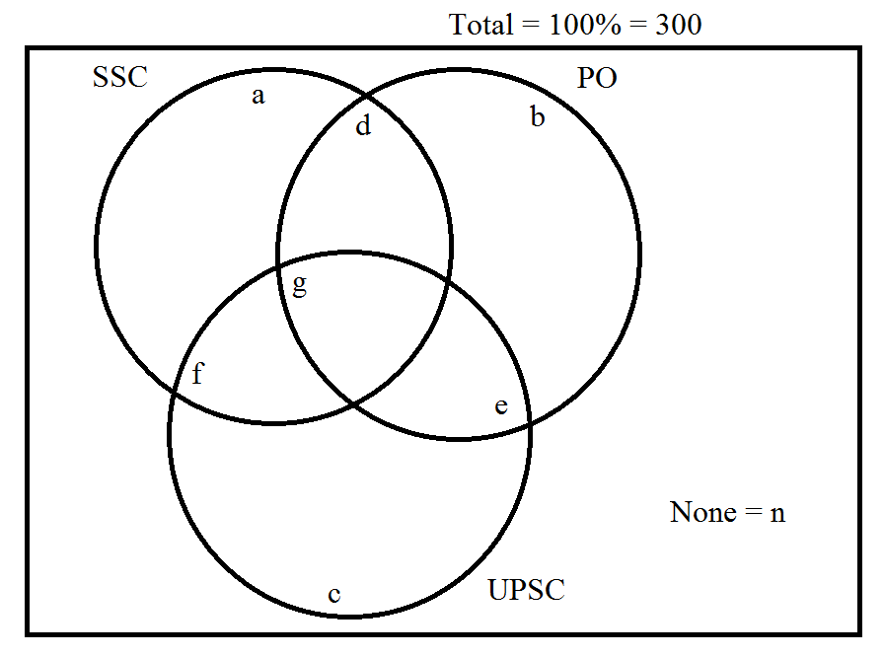

a+d+f+g = 45%___1

b+d+e+g = 43%___2

c+e+f+g = 40%___3

d+g = 10%___4

e+g = 12%___5

f+g = 15%___6

n = 5%

a+b+c+d+e+f+g+n = 100%

a+b+c+d+e+f+g = 95%___7

Adding equation 1, 2 and 3

a+b+c+2.(d+e+f)+3.g = 128%___8

Adding equation 4, 5 and 6

d+e+f+3.g= 37%___9

Subtracting 9 from 8

a+b+c+d+e+f = 91%___10

Solving 7 and 10 we hey g = 4%

Putting the value of 'g' in equarion 4, 5 and 6 we get,

d = 6%

e = 8%

f = 11%

now from equation 1, 2 and 3 we get,

a = 24%

b = 25%

c = 17%

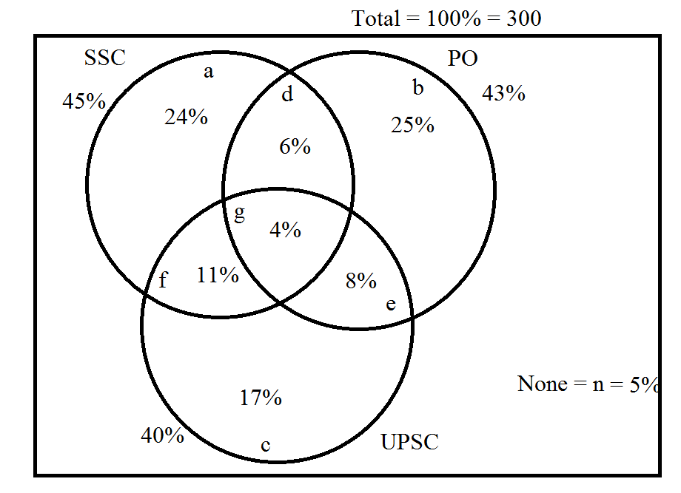

1) How many candidates are appearing for all the three exams?

Total candidates appearing for all the 3 exams = g = 4%

So, 100% corresponds to 300, then 4% corresponds to 12.

**a) 12** b) 13 c) 14 d) 15 e) 16

2) How candidates are appearing for exactly one exam?

Candidate appearing for exactly one exam = 24%+25%+17% = 66%

100%---300

66%----198

a) 200 b) 216 **c) 198** d) 194 e) 208

3) What is the percentage change in number of candidates appearing for exactly two exams when total changes from 300 to 450?

Total number of candidates = 300

Candidates passed in exactly 2 exams = 25%

100% corresponds to 300

25% corresponds to 75

If total number of candidates = 450

Candidates passed in exactly 2 exams = 25%

100% corresponds to 450

25% corresponds to 112.5

percentage change in number of candidates appearing for exactly two exams when total changes from 300 to 450 =

**= 50%**

a) 10% b) 20% c) 30% d) 40% **e) 50%**

4) What is the ratio of the number of candidates appearing for SSC but not for PO to the number of candidates appearing for PO but not for SSC?

=

a) 33:35 **b) 35:33** c) 31:33

d) 33:31 e) 35:31

5) What percent of candidates are appearing for at least two exams?

Candidates are appearing for at least two exams = Candidate appearing for exactly 2 exams + Candidates appearing for exactly 3 exams

= (11% + 6% + 8%) + 4%

= 31%

a) 25% b) 29% c) 27% **d) 31%** e) 26%

6) How many candidates are appearing for at most two exams?

Candidates are appearing for at most two exams = Candidates appearing exactly 2 exams + Candidates appearing exactly 1 exams + Candidates appearing for none of the exams

= (11% + 6% + 8%) + (24%+25%+17%) + 5%

= 96%

a) 94% b) 91% c) 90% d) 71% **e) 96%**

**Cubes**

**Direction :** A solid cube of 12 cm been painted green , blue and yellow on pairs of opposite faces . it is then cut in cubical blocks of each side 3 cm.

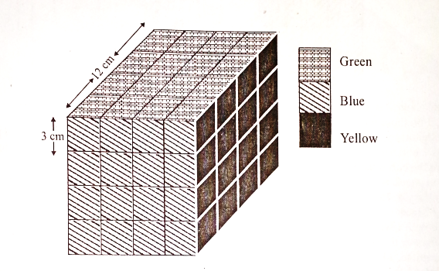

1. How many cubes have only one face painted?

Number of cubes only one face is painted = Pieces along a face except the corner pieces and pieces along the edges 6(Total number of faces of cube)

= 4 6 = 24

1) 8 2)16 **3)24** 4) 28

2. How many cubes have only two faces painted?

Number of cubes only two faces is painted = Pieces along a edge except the corner pieces 12(Total number of edges of cube)

= 4 6 = 24

1) 8 2)16 3)20 **4) 24**

3. How many cubes have only three faces painted?

Number of cubes Exactly three faces is painted = Pieces which are at the corners = 8

1) 0 2) 4 3) 6  **4) 8**

4. How many cubes have no face painted?

= Total number of pieces - Number of pieces whose at least one face is painted(Number of cubes only one face is painted+ Number of cubes only two faces is painted+ Number of cubes Exactly three faces is painted)

= 64 - ( 24+24+8)

= 8

OR

Total number of pieces of bigger cube = 6

If we remove the outer layer then number of pieces inside that cube = 2 8

1) 0 2) 4 **3) 8** 4)12

5. How many cubes have at most one face painted?

Number of pieces whose at most one face is painted = Total number of pieces - Number of pieces whose exactly two or three faces are painted

= 64 - (8+24)

= 32

1) 24 2) 32 3) 30 4) 36

6. How many cubes have two faces painted yellow and green and all other faces unpainted?

There are four edges where exactly two faces of piece get painted by yellow and green colour.

cubes have two faces painted yellow and green and all other faces unpainted = Number of pieces along that single edge 4

= 2 4 = 8

1) 4 **2) 8** 3)16 4) 32

**Data Interpretation**

**Directions for questions 1 to 5**

These questions are based on the following information.

The total population of village Satana is 3550, out of which 36% people are below poverty line. The total population of Satana is 11 1/4% less than the total population of Amin, while there are 29% people in Amin who lives below poverty line. In Nilokheri the people living below poverty line are 40 more than that in Amin which is 40% of the total population of this village. The average population of Gharaunda and Samalkha is equal to the average population of Amin and Nilokheri, while the difference between their population is 1800 (Village Samalkha is more populated). 47% of the population of Gharaunda are below poverty line.

Overall 46% of the population of all villages; together lives below poverty line

|  |  |  |  |
| --- | --- | --- | --- |
|  | Population below poverty line | Population above poverty line | Total population |
| Satana | 1278 | 2272 | 3550 |
| Amin | 1160 | 2840 | 4000 |
| Gharaunda | 1222 | 1378 | 2600 |
| Samalkha | 3213 | 1187 | 4400 |
| Nilokheri | 1200 | 1800 | 3000 |
|  | 8073 | 9477 | 17550 |

1) What percentage of population of Samalkha lives above poverty line? (Approximate)

= × 100 = 26.977% =27%

a) 26%  **b) 27%** c) 28% d) 29% e) 30%

2) Find the approximate average number of people below poverty line in the given villages.

= = 1614.6 =1615

a) 1610 b) 1620 c) 1615 d) 1320 e) 1730

3) If 35% of the BPL population of Nilokheri are children, while 30% of the overall population of this village are children. Then what percent of population above poverty line are children?

Total number of children in Nilokheri = 30% of 3000 = 900

Children in Nilokheri who are below poverty line = 35% of 1200 = 420

Children in Nilokheri who are above poverty line = 900 - 420 = 480

Percent of population above poverty line are children = = 12%

a) 25% b) 30% c) 26 1/3 % d) 26 2/3 % **e) None of these**

4) What is the difference between total population of Nilokheri and that of Gharaunda?

= 3000 - 2600 = 400

a) 300 b) 200 c) 250 d) 400 e) None of these

5) If in the next year the total population of Amin would increase by 20%, while BPL population would decrease by 25%, then what percent of population in next year would be below poverty line?

Next year population in Amin next year = 4800

Below poverty line population in Amin = 870

percent of population in next year would be below poverty line = 100 = 18.125%

a) 18.125% b) 18.325% c) 18.225% d) 18.525% e) None of these

**Directions for questions 6 to 10**

These questions are based on the following data.

The following tables gives the information about the number of students applied, appeared and passed from various schools in different years.



X - Applied; Y - Appeared; Z - Passed

Passed Percentage =100

Percentage of Attendance = 100

6) In 2001, which school has the least pass percentage?

A = 85.5%

B = 80%

C = 100%

D = 70%

E = 92.30%

a) A b) B c) C **d) D** e) E

7) For B, in which year the percentage of attendance the least?

2000 = = 83.33%

2001 = = 83.33%

2002 = = 92.5%

2003 = = 80%

a) 2000 b) 2001 c) 2002 **d) 2003**  e) Cannot be determined

8) The ratio of total number o students who passed in 2000 to that in 2003 in all the schools is.

= = =

a) 104:132 b) 185:233 c) 4:7 d) 7:11 e) None of these

9) In how many instances is the pass percentage of any school in any year less than 80%?

School D - 2001

a) 0 **b) 1** c) 2 d) 3 e) 4

10) The number of students who passed in 2002 from school B is approximately how many times that in 2000 from A?

= = = 1.26

a) 2 b) 2.2 c) 3 d) 2.6 e) 1.8

**Directions for questions 11 to 15**

The following graph shows the profit percentage earned by three companies Aryan Holding, Arban Enterprises and Anirban Pvt Ltd over the given years.

% Profit = 100

Income = Expenditure + Profit

Profit = x% of Expenditure

11) If the income of Arban Enterprises in 2005 was Rs. 12 lakh, what was the approximate profit earned, in lakh rupees, in that year?

We assume the Expenditure in that year as 100.

Profit % of Arban Enterprises in 2005 = 35%

|  |  |  |  |
| --- | --- | --- | --- |
| Expenditure | 100 |  |  |
| Profit | 35 |  |  |
| Income | 135 | 12 lakh |  |

135 corresponds to 12 lakh then profit i.e. 35 corresponds to = 3.11 lakh

a) 8 b) 3 c) 16 d) 11.5 e) 2.5

12) If the expenditure of Arban Enterprises in 2007 is equal to that of Anirban Pvt Ltd in 2008, what was the ratio of the income of Arban Enterprises in 2007 to that of Anirban Pvt Ltd in 2008?

Expenditure of Arban Enterprises in 2007 = Expenditure of Anirban Pvt Ltd in 2008 = 100(Assumed value)

Arban Enterprises in 2007

Profit % = 35%

|  |  |
| --- | --- |
| Expenditure | 100 |
| Profit | 35 |
| Income | 135 |

Anirban Pvt Ltd in 2008

Profit % = 45%

|  |  |
| --- | --- |
| Expenditure | 100 |
| Profit | 45 |
| Income | 145 |

Ratio of Income = =

a) 4:5 b) 39:40 **c) 27:29**  d) 3:4 e) None of these

13) Income of Anirban Pvt Ltd in 2003 and 2005 were equal. What was ratio of its expenditure in 2003 to that in 2005?

Anirban Pvt Ltd in 2003

Profit % = 40%

|  |  |
| --- | --- |
| Expenditure | 100x |
| Profit | 40x |
| Income | 140x |

Anirban Pvt Ltd in 2005

Profit % = 25%

|  |  |
| --- | --- |
| Expenditure | 100y |
| Profit | 25y |
| Income | 125y |

Income of Anirban Pvt Ltd in 2003 and 2005 were equal.

140x = 125y

= =

Ratio of Expenditure = =

a) 28:25 b) 1:5 c) 16:23 d) 9:7 **e) 25:28**

14) Income of Aryan Holdings in 2006 is equal to its expenditure in 2007. What is the ratio of its income in 2007 to that in 2005?

Expenditure of Aryan Holdings in 2006 = 100(Assumed Value)

Profit % = 40%

|  |  |
| --- | --- |
| Expenditure | 100 |
| Profit | 40 |
| Income | 140 |

Income of Aryan Holdings in 2006 is equal to its expenditure in 2007.

So, Expenditure of Aryan holdings in 2007 = 140

Profit % of Aryan Holdings in 2007 = 30%

|  |  |
| --- | --- |
| Expenditure | 140 |
| Profit | 42 |
| Income | 182 |

Aryan Holding in 2005

Expenditure of Aryan holdings in 2007 = 100(Assumed Value)

Profit % =

|  |  |  |  |
| --- | --- | --- | --- |
| Expenditure | 100(Assumed) | 200(Assumed) | 300(Assumed) |
| Profit | 30 | 60 | 90 |
| Income | 130 | 260 | 390 |

If we assumed different values for the expenditure then we get different ratios, So answer is Cannot be determine.

a) 3:7 b) 1:1 c) 91:50 d) 10:13 **e) Cannot be determined**

15) In which year is the percentage rise /fall in the percentage of profit earned by Aryan Holdings the best?

In the year 2005 percentage rise /fall in the percentage of profit earned by Aryan Holdings is best i.e. 100%

a) 2004 b) 2006 c) 2008 d) 2005 e) 2007

**Directions for questions 11 to 15**

This questions are based on the pie-charts given below.

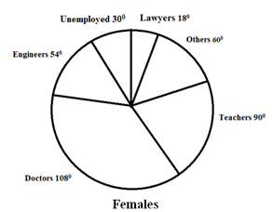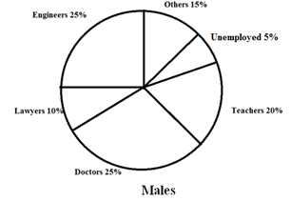

The above two pie chart gives the distribution of the adults in the city .

The total number of adults = 98000

The ratio of number of males to that of females among the adults in the city is 25:24.

|  |  |  |
| --- | --- | --- |
|  | Male | Female |
| Unemployed | 5% 2500 | 300 4000 |
| Engineers | 25% 12500 | 540  7200 |
| Doctors | 25% 12500 | 1080 14400 |
| Teachers | 20% 10000 | 900 12000 |
| Others | 15% 7500 | 600  8000 |
| Lawyers | 10% 5000 | 180 2400 |
| Total : | 100% 50000 | 3600  48000 |

16) What is the difference between the number of male lawyers and female lawyers?

**a) 2600** b) 2400 c) 2480 d) 2530 e) 2440

17) What is the number of females lawyers in the city?

**a) 2400**  b) 12200 c) 12000 d) 10800 e) 15000

18) What is the total number of engineers in the city?

a) 12500 b) 7200 **c) 19700**  d) 20700 e) None of these

19) The number of males who are unemployed as the percentage of total unemployed person in the city is.

100 = 38.46% = 38.5%

a) 40% b) 50.5% c) 56.5% **d) 38.5%** e) 34.5%

20) What is the ratio of total number of engineers to that of teachers in the city?

= =

a) 146:201 b) 79:84 c) 35:43 **d) 197:220** e) 211:233